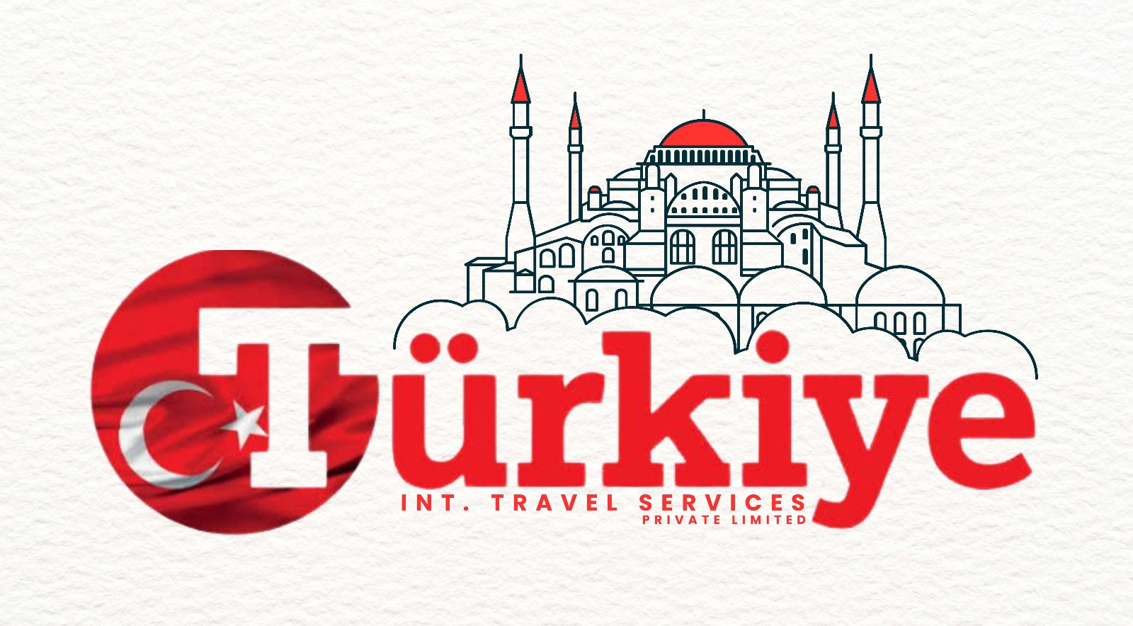

CHECKLIST FOR VISA APPLICATION FILE
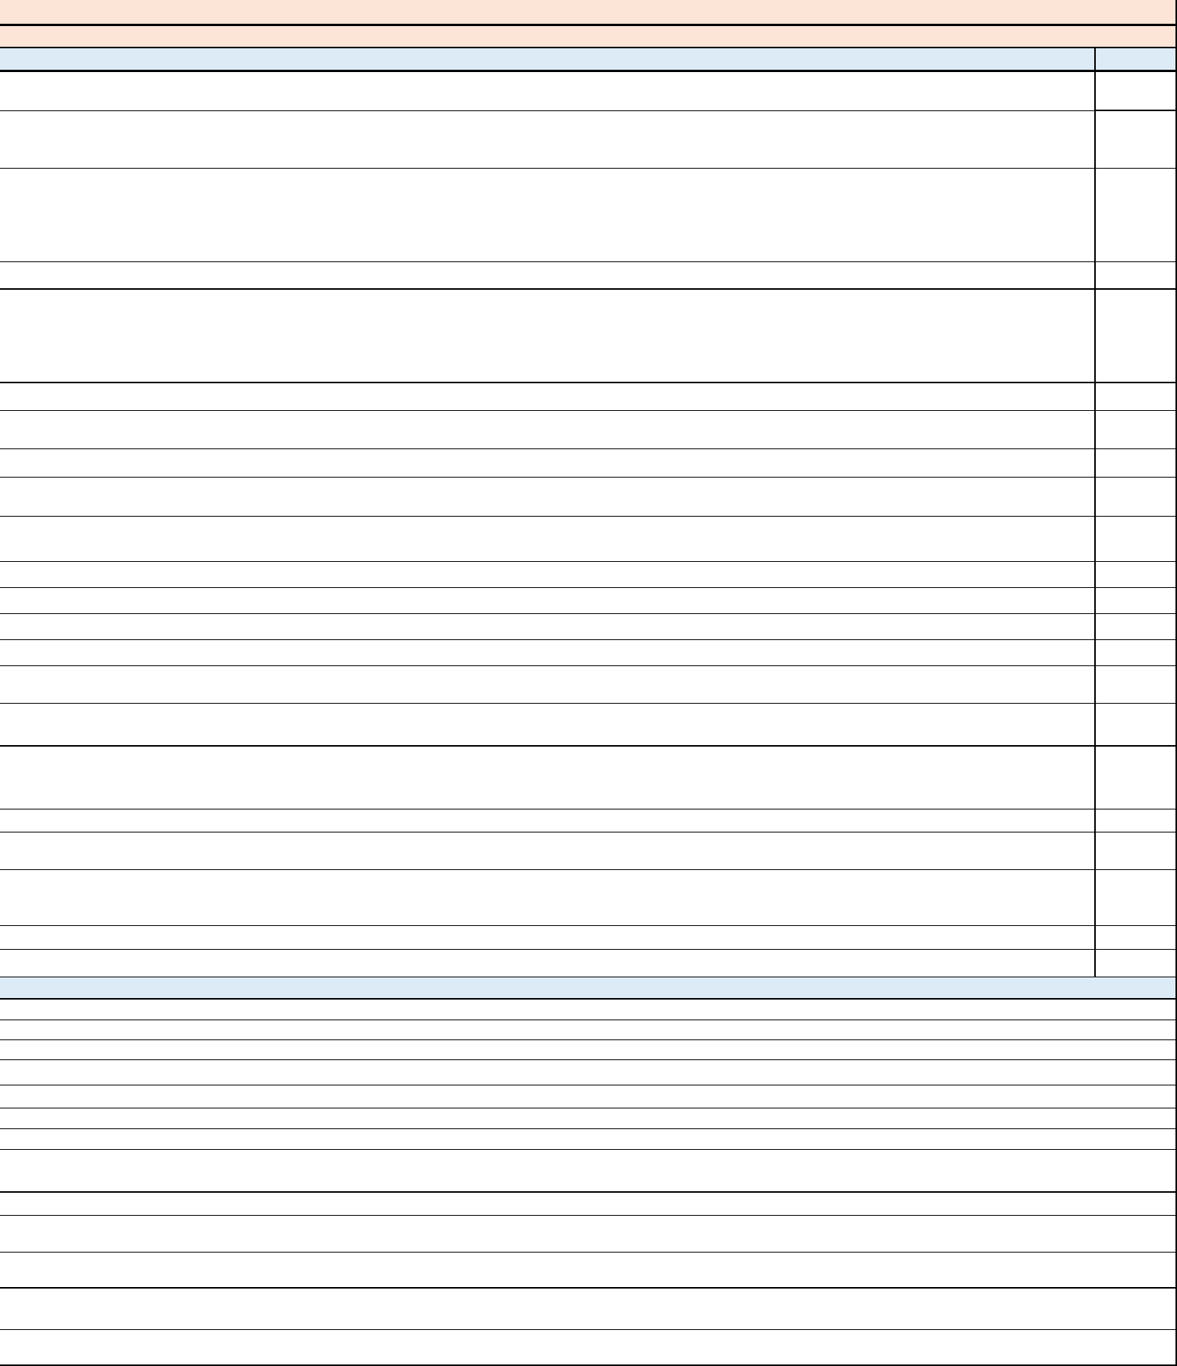

(WORK PURPOSE)

Mandatory Documents

Submitted

Please note that below list of documents will be used depending on the occupation and personal circumstances of individual. All the below mentioned documents are not for each individual visa application.

Visa Application Form (VAF) duly filled and printed at Turkiye International Travel Services Travel Services by office staff in accordance with the information given by the applicant with recent two colored biometric photos attached to it (White Background - 5x5cm size) Front pose without eye glasses (only applicable for Punjab.), sun glasses, veil, cap, Turban (80% face 20% body) Photoshop and light shadow pictures are not acceptable. Printed VAF should be checked and signed by the applicant.

Unimpaired Passport / Travel Document valid for 180 days (Single Entry Visa) and 365 days (Multiple Entry Visa) from the travel date, and copies of the Bio Data and used pages of the current and old passports (Maximum last 10 years travel history) only on A4 size pages and minimum two blank visa pages (Back to back) should be available in the passport. Foreigner passport holders must have at least one-month valid visa and duration of stay in Pakistan from the date of submission at Turkiye International Travel Services Visa Application Center. For Afghan nationals, Pakistani visa should be valid for minimum 90 days at the time of submission at Turkiye International Travel Services Visa Application Centers and their passport must be valid for 180 days from the date of travel.

If the old passport of the applicant is lost, Police report and it's Notarized translation to English is required.

Typed / computerized original one page (A4 size) cover letter on plain paper (Mandatory for the applicant's age of 18 and elder) . (For businessmen on their business letterheads) where applicants explaining details e.g. introduction, the purpose of visit, the intend travel dates, the places to be visited, who will bear the tour expenses, who the applicant is traveling with, whether applicant has been in Türkiye before, etc. However, for families and Corporate Groups, it's only required from the family head (by giving additional family details e.g. name, passport number and relationship) and Corporate office (on business letterhead) respectively (by giving additional applicants details e.g. name, passport number, designation and city of employment / operations).

Updated original Police Character Certificate is required which should be attested by the MOFA (Ministry of Foreign Affairs) Pakistan.

Family Registration Certificate (with spouse and children if the applicant is married) or Marriage Registration Certificate (For newly married couples within 90 days from the wedding date) from NADRA office. If the applicant is single, FRC is required with siblings.

One-way flight reservation is required. It is not advisable to purchase flight ticket prior to getting visa and passport back from the Visa Application Center.

Employment Contract (Belirli Süreli İş Sözleşmesi) must be submitted as original which should contain employment duration and title clearly and should be signed/stamped by both parties.

Employment Contracts (Belirli Süreli İş Sözleşmesi) announced by “Turkish Ministry of Labor and Social Security” must be filled through provided link.

https://www.csgb.gov.tr/uigm/belgeler/is-sozlesmesi/. Other contracts will not be accepted.

Türkiye company Tax Registration Certificate / Firma Vergi Levhası

Türkiye company status certificate / Faaliyet Belgesi

Türkiye company Trade Registry / Ticaret Sicil Kaydı

Türkiye company Specimen Signature from Notary / Noterden alınan İmza Beyannamesi

Request letter along with the title of the Employee should be mentioned by the employer company from Türkiye along with ID and contact details of authorized person of the Employer Company.

Embassy/Consulates General of the Republic of Türkiye recommend that the applications for visa would be submitted within a range of 14 days to 3 months prior to the date of travel.

Please note that this does not necessarily mean that the visa application will be processed within 14 days.

Travel Health Insurance Certificate amounting to coverage of 60.000 US Dollars which covers the period of stay in Türkiye also, including repatriation costs is compulsory. According to rules that is applicable from January, 2023, Travel Heath Insurances should be for fixed durations, namely, 3 months, 6 months or 12 months. Only Travel Health Insurances which are made in Turkiye International Travel Services Visa Application Centers across Pakistan will be accepted. No other insurances will be accepted.

If the applicant is a government officer, Ex-Pakistan Leave Paper or NOC is required. Retirement proof or pensioner proof if applicable.

If the applicant declared that he/she is traveling with an accompanying person who already had a valid Türkiye sticker visa / E-Visa/ Residency Permit, a copy of the aforementioned document and proof of air ticket reservation of the accompanying person are required.

If the applicant is owner of a business, supporting documents proving ownership (e.g. Business letter head / Business NTN / Partnership Deed / SECP Certification / Form 29 / Memorandum of Article / Memorandum of Association / Copy of valid chamber certificate or card) as well as official documents showing company's financial standing. Copy of valid license required if applicable for e.g , DTS, DRA, Food Authority etc. when applicable.

If the applicant is a professional, Professional Qualification Certificate (Valid PMDC / Engineering Council / Bar Associate Letters, etc.) / Skill Certificate is required.

Applicant under 18 years old, are not eligible to apply for work visa as per the Turkiye Government laws .

UNDERTAKING (PLEASE READ CAREFULLY BEFORE SIGNATURES)

I declare that all the documents I presented to Turkiye International Travel Services officers are correctly recorded with a tick on the "submission" column on the checklist paper.

I understand that my intended travel date does not necessarily indicate that my visa application will be finalized before my travel date.

I am informed that submitting necessary documents does not necessarily lead to visa issuance.

I have been informed that earliest date which I can apply for a visa is 3 months prior to the intended travel date.

I understand that all documents I presented should be in English (Notarized translation is accepted), readable, scan able, and in A4 format.

I hereby certify that all submitted documents are genuine and all information provided is correct.

I understand that submitting supporting documents may lead to a more accurate decision against my visa application in a relatively shorter period of time.

I am informed that in case of submission of fake / forged documents, the Embassy / Consulates of the Republic of Türkiye will send the application file along with the passport of the applicant to the Ministry of Foreign Affairs of the Islamic Republic of Pakistan with a view to initiating a legal process.

I understand that submission of fake/forged documents may end up with an entry ban to Türkiye.

I understand that any incorrect information may cause to refusal of my visa application and the Embassy / Consulates of the Republic of Türkiye reserve the right not to disclose verbal or written any reason for refusal to the applicant or Turkiye International Travel Services officers.

I hereby give my consent that all the documents I presented can be verified by the Embassy / Consulates of the Republic of Türkiye in Islamabad / Lahore / Karachi or/and Turkiye International Travel Services Travel Services offices across Pakistan.

Signature of the Applicant: _____________________________

Date: _______/_______/2024

